**DS Lab Week #6**

Angad Sandhu

190905494

1/04/2022

**solved questions**

**1)**

**#server.py**

import socket

import datetime

import time

# function used to initiate the Clock Server

def initiateClockServer():

s = socket.socket()

print("Socket successfully created")

# Server port

port = 8011

s.bind(('', port))

# Start listening to requests

s.listen(5)

print("Socket is listening...")

# Clock Server Running forever

while True:

# Establish connection with client

connection, address = s.accept()

print('Server connected to', address)

# Respond the client with server clock time

connection.send(str(datetime.datetime.now()).encode())

# Close the connection with the client process

connection.close()

# Driver function

if __name__ == '__main__':

# Trigger the Clock Server

initiateClockServer()

**#client.py**

import socket

import datetime

from dateutil import parser

from timeit import default_timer as timer

# function used to Synchronize client process time

def synchronizeTime():

s = socket.socket()

# Server port

port = 8011

# connect to the clock server on local computer

s.connect(('127.0.0.1', port))

request_time = timer()

# receive data from the server

server_time = parser.parse(s.recv(1024).decode())

response_time = timer()

actual_time = datetime.datetime.now()

print("Time returned by server: " + str(server_time))

process_delay_latency = response_time - request_time

print("Process Delay latency: " + str(process_delay_latency) + " seconds")

print("Actual clock time at client side: " + str(actual_time))

# synchronize process client clock time

client_time = server_time + datetime.timedelta(seconds = (process_delay_latency) / 2)

print("Synchronized process client time: " + str(client_time))

# calculate synchronization error

error = actual_time - client_time

print("Synchronization error : " + str(error.total_seconds()) + " seconds")

s.close()

# Driver function

if __name__ == '__main__':

# synchronize time using clock server

synchronizeTime()

**Output:**

**Server**

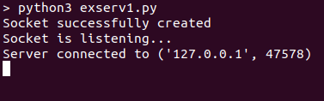

**Client**

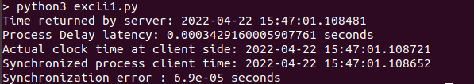

**2)**

**#server.py**

from functools import reduce

from dateutil import parser

import threading

import datetime

import socket

import time

# datastructure used to store client address and clock data

client_data = {}

''' nested thread function used to receive

clock time from a connected client '''

def startRecieveingClockTime(connector, address):

while True:

# recieve clock time

clock_time_string = connector.recv(1024).decode()

clock_time = parser.parse(clock_time_string)

clock_time_diff = datetime.datetime.now() - \

clock_time

client_data[address] = {

"clock_time" : clock_time,

"time_difference" : clock_time_diff,

"connector" : connector

}

print("Client Data updated with: "+ str(address),

end = "\n\n")

time.sleep(5)

''' master thread function used to open portal for

accepting clients over given port '''

def startConnecting(master_server):

# fetch clock time at slaves / clients

while True:

# accepting a client / slave clock client

master_slave_connector, addr = master_server.accept()

slave_address = str(addr[0]) + ":" + str(addr[1])

print(slave_address + " got connected successfully")

current_thread = threading.Thread(

target = startRecieveingClockTime,

args = (master_slave_connector,

slave_address, ))

current_thread.start()

# subroutine function used to fetch average clock difference

def getAverageClockDiff():

current_client_data = client_data.copy()

time_difference_list = list(client['time_difference']

for client_addr, client

in client_data.items())

sum_of_clock_difference = sum(time_difference_list, \

datetime.timedelta(0, 0))

average_clock_difference = sum_of_clock_difference \

/ len(client_data)

return average_clock_difference

def synchronizeAllClocks():

while True:

print("New synchroniztion cycle started.")

print("Number of clients to be synchronized: " + \

str(len(client_data)))

if len(client_data) > 0:

average_clock_difference = getAverageClockDiff()

for client_addr, client in client_data.items():

try:

synchronized_time = \

datetime.datetime.now() + \

average_clock_difference

client['connector'].send(str(

synchronized_time).encode())

except Exception as e:

print("Something went wrong while " + \

"sending synchronized time " + \

"through " + str(client_addr))

else :

print("No client data." + \

" Synchronization not applicable.")

print("\n\n")

time.sleep(5)

# function used to initiate the Clock Server / Master Node

def initiateClockServer(port = 8080):

master_server = socket.socket()

master_server.setsockopt(socket.SOL_SOCKET, socket.SO_REUSEADDR, 1)

print("Socket at master node created successfully\n")

master_server.bind(('', port))

# Start listening to requests

master_server.listen(10)

print("Clock server started...\n")

# start making connections

print("Starting to make connections...\n")

master_thread = threading.Thread(

target = startConnecting,

args = (master_server, ))

master_thread.start()

# start synchroniztion

print("Starting synchronization parallely...\n")

sync_thread = threading.Thread(

target = synchronizeAllClocks,

args = ())

sync_thread.start()

# Driver function

if __name__ == '__main__':

# Trigger the Clock Server

initiateClockServer(port = 8080)

**#client.py**

from timeit import default_timer as timer

from dateutil import parser

import threading

import datetime

import socket

import time

# client thread function used to send time at client side

def startSendingTime(slave_client):

while True:

# provide server with clock time at the client

slave_client.send(str(

datetime.datetime.now()).encode())

print("Recent time sent successfully",

end = "\n\n")

time.sleep(5)

# client thread function used to receive synchronized time

def startReceivingTime(slave_client):

while True:

# receive data from the server

Synchronized_time = parser.parse(

slave_client.recv(1024).decode())

print("Synchronized time at the client is: " + \

str(Synchronized_time),

end = "\n\n")

# function used to Synchronize client process time

def initiateSlaveClient(port = 8080):

slave_client = socket.socket()

# connect to the clock server on local computer

slave_client.connect(('127.0.0.1', port))

# start sending time to server

print("Starting to receive time from server\n")

send_time_thread = threading.Thread(

target = startSendingTime,

args = (slave_client, ))

send_time_thread.start()

# start recieving synchronized from server

print("Starting to recieving " + \

"synchronized time from server\n")

receive_time_thread = threading.Thread(

target = startReceivingTime,

args = (slave_client, ))

receive_time_thread.start()

# Driver function

if __name__ == '__main__':

# initialize the Slave / Client

initiateSlaveClient(port = 8080)

**Output:**

**Server**

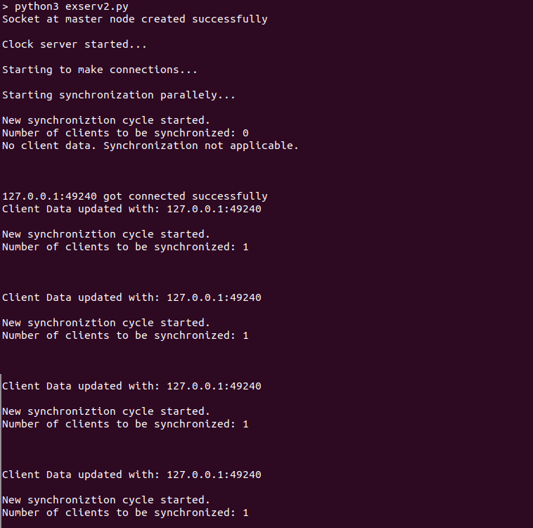

**Client**

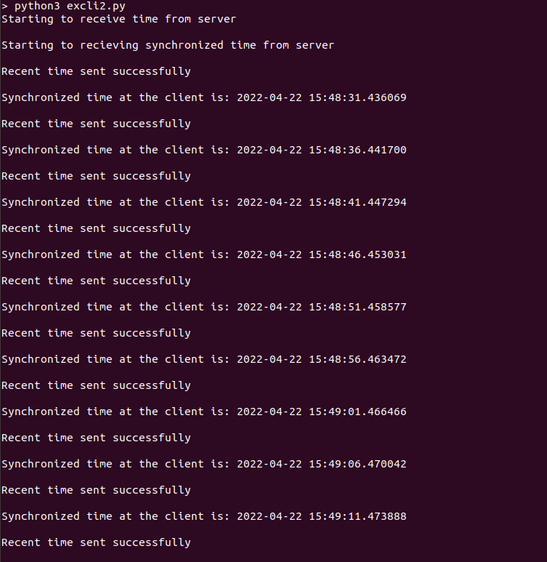

**exersize questions**

**1)**

**#server.py**

from functools import reduce

from dateutil import parser

import threading

import datetime

import socket

import time

client_data = {}

def startRecieveingClockTime(connector, address):

while True:

clock_time_string = connector.recv(1024).decode()

clock_time = parser.parse(clock_time_string)

clock_time_diff = datetime.datetime.now() - clock_time

client_data[address] = {

"clock_time": clock_time,

"time_difference": clock_time_diff,

"connector": connector

}

print("Client Data updated with: " + str(address), end="\n\n")

time.sleep(5)

def startConnecting(master_server):

while True:

master_slave_connector, addr = master_server.accept()

slave_address = str(addr[0]) + ":" + str(addr[1])

print(slave_address + " got connected successfully")

current_thread = threading.Thread(

target=startRecieveingClockTime,

args=(master_slave_connector, slave_address, ))

current_thread.start()

def getAverageClockDiff():

current_client_data = client_data.copy()

time_difference_list = list(client['time_difference']

for client_addr, client in client_data.items())

sum_of_clock_difference = sum(

time_difference_list, datetime.timedelta(0, 0))

average_clock_difference = sum_of_clock_difference / len(client_data)

return average_clock_difference

def synchronizeAllClocks():

while True:

print("New synchroniztion cycle started.")

print("Number of clients to be synchronized: " + str(len(client_data)))

if len(client_data) > 0:

average_clock_difference = getAverageClockDiff()

for client_addr, client in client_data.items():

try:

synchronized_time = datetime.datetime.now() + average_clock_difference

client['connector'].send(str(synchronized_time).encode())

except Exception as e:

print("Something went wrong while sending synchronized time through" + str(client_addr))

else:

print("No client data. Synchronization not applicable.")

print("\n\n")

time.sleep(5)

def initiateClockServer(port=8059):

master_server = socket.socket()

master_server.setsockopt(socket.SOL_SOCKET, socket.SO_REUSEADDR, 1)

print("The Manipal Foodie\n")

master_server.bind(('', port))

master_server.listen(10)

print("Clock server print\n")

print("Connecitng to production lines...\n")

master_thread = threading.Thread(

target=startConnecting,

args=(master_server, ))

master_thread.start()

print("Starting synchronization parallely...\n")

sync_thread = threading.Thread(

target=synchronizeAllClocks,

args=())

sync_thread.start()

if __name__ == '__main__':

initiateClockServer(port=8059)

**#client1.py**

from timeit import default_timer as timer

from dateutil import parser

import threading

import datetime

import socket

import time

def startSendingTime(slave_client):

while True:

slave_client.send(str(datetime.datetime.now()).encode())

print("KMC time sent successfully", end="\n\n")

time.sleep(5)

def startReceivingTime(slave_client):

while True:

Synchronized_time = parser.parse(slave_client.recv(1024).decode())

print("Synchronized time at the client is: " +

str(Synchronized_time), end="\n\n")

def initiateSlaveClient(port=8059):

slave_client = socket.socket()

slave_client.connect(('127.0.0.1', port))

print("Starting to receive time from server\n")

send_time_thread = threading.Thread(

target=startSendingTime,

args=(slave_client, ))

send_time_thread.start()

print("Starting to recieving synchronized time from server\n")

receive_time_thread = threading.Thread(

target=startReceivingTime,

args=(slave_client, ))

receive_time_thread.start()

if __name__ == '__main__':

initiateSlaveClient(port=8059)

**#client2.py**

from timeit import default_timer as timer

from dateutil import parser

import threading

import datetime

import socket

import time

def startSendingTime(slave_client):

while True:

slave_client.send(str(datetime.datetime.now()).encode())

print("MIT time sent successfully", end="\n\n")

time.sleep(5)

def startReceivingTime(slave_client):

while True:

Synchronized_time = parser.parse(slave_client.recv(1024).decode())

print("Synchronized time at the client is: " +

str(Synchronized_time), end="\n\n")

def initiateSlaveClient(port=8059):

slave_client = socket.socket()

slave_client.connect(('127.0.0.1', port))

print("Starting to receive time from server\n")

send_time_thread = threading.Thread(

target=startSendingTime,

args=(slave_client, ))

send_time_thread.start()

print("Starting to recieving synchronized time from server\n")

receive_time_thread = threading.Thread(

target=startReceivingTime,

args=(slave_client, ))

receive_time_thread.start()

if __name__ == '__main__':

initiateSlaveClient(port=8059)

**#client3.py**

from timeit import default_timer as timer

from dateutil import parser

import threading

import datetime

import socket

import time

def startSendingTime(slave_client):

while True:

slave_client.send(str(datetime.datetime.now()).encode())

print("TAPMI time sent successfully", end="\n\n")

time.sleep(5)

def startReceivingTime(slave_client):

while True:

Synchronized_time = parser.parse(slave_client.recv(1024).decode())

print("Synchronized time at the client is: " +

str(Synchronized_time), end="\n\n")

def initiateSlaveClient(port=8059):

slave_client = socket.socket()

slave_client.connect(('127.0.0.1', port))

print("Starting to receive time from server\n")

send_time_thread = threading.Thread(

target=startSendingTime,

args=(slave_client, ))

send_time_thread.start()

print("Starting to recieving synchronized time from server\n")

receive_time_thread = threading.Thread(

target=startReceivingTime,

args=(slave_client, ))

receive_time_thread.start()

if __name__ == '__main__':

initiateSlaveClient(port=8059)

**#client4.py**

from timeit import default_timer as timer

from dateutil import parser

import threading

import datetime

import socket

import time

def startSendingTime(slave_client):

while True:

slave_client.send(str(datetime.datetime.now()).encode())

print("SOLS time sent successfully", end="\n\n")

time.sleep(5)

def startReceivingTime(slave_client):

while True:

Synchronized_time = parser.parse(slave_client.recv(1024).decode())

print("Synchronized time at the client is: " + str(Synchronized_time), end="\n\n")

def initiateSlaveClient(port=8059):

slave_client = socket.socket()

slave_client.connect(('127.0.0.1', port))

print("Starting to receive time from server\n")

send_time_thread = threading.Thread(

target=startSendingTime,

args=(slave_client, ))

send_time_thread.start()

print("Starting to recieving synchronized time from server\n")

receive_time_thread = threading.Thread(

target=startReceivingTime,

args=(slave_client, ))

receive_time_thread.start()

if __name__ == '__main__':

initiateSlaveClient(port=8059)

**Output:**

**Server:**

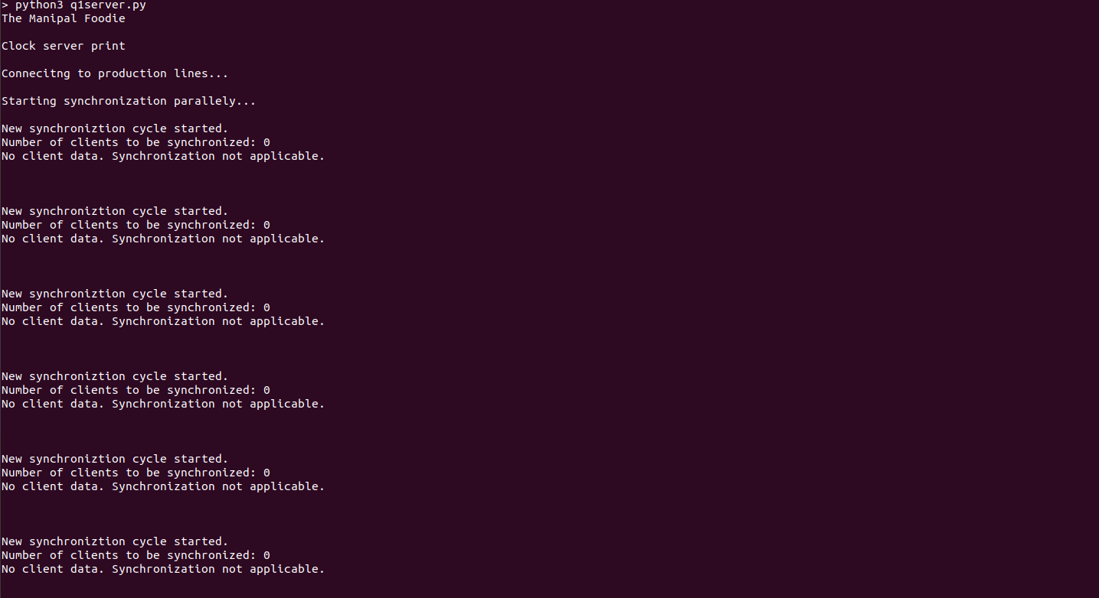

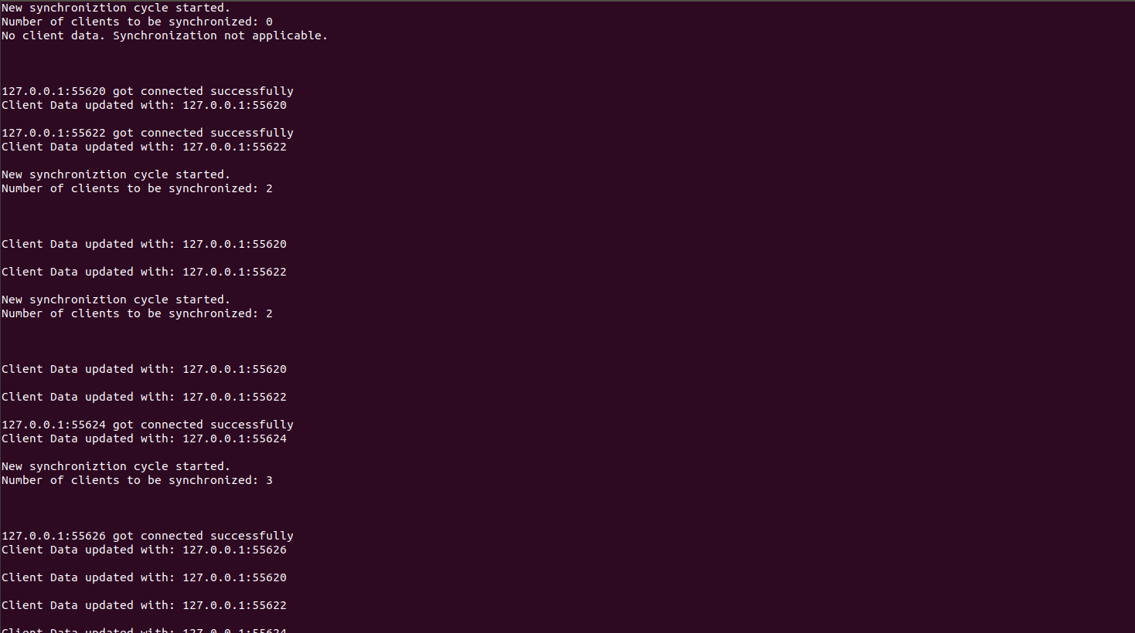

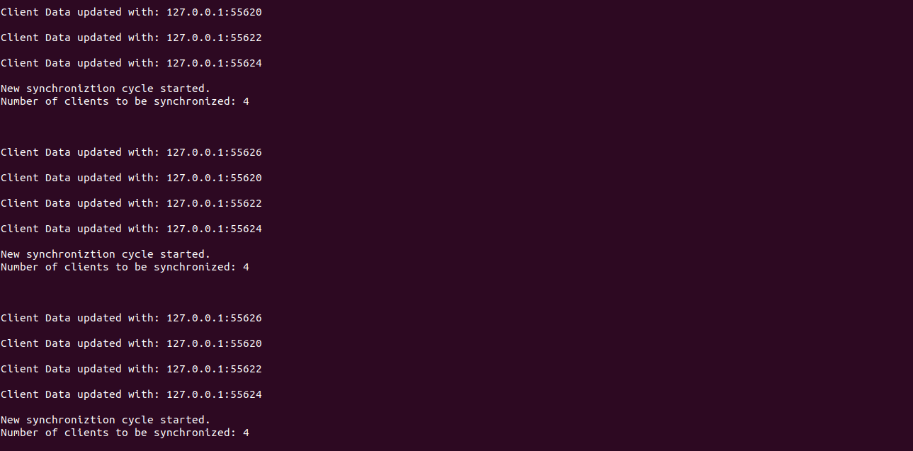

**Client 1 & Client 2**

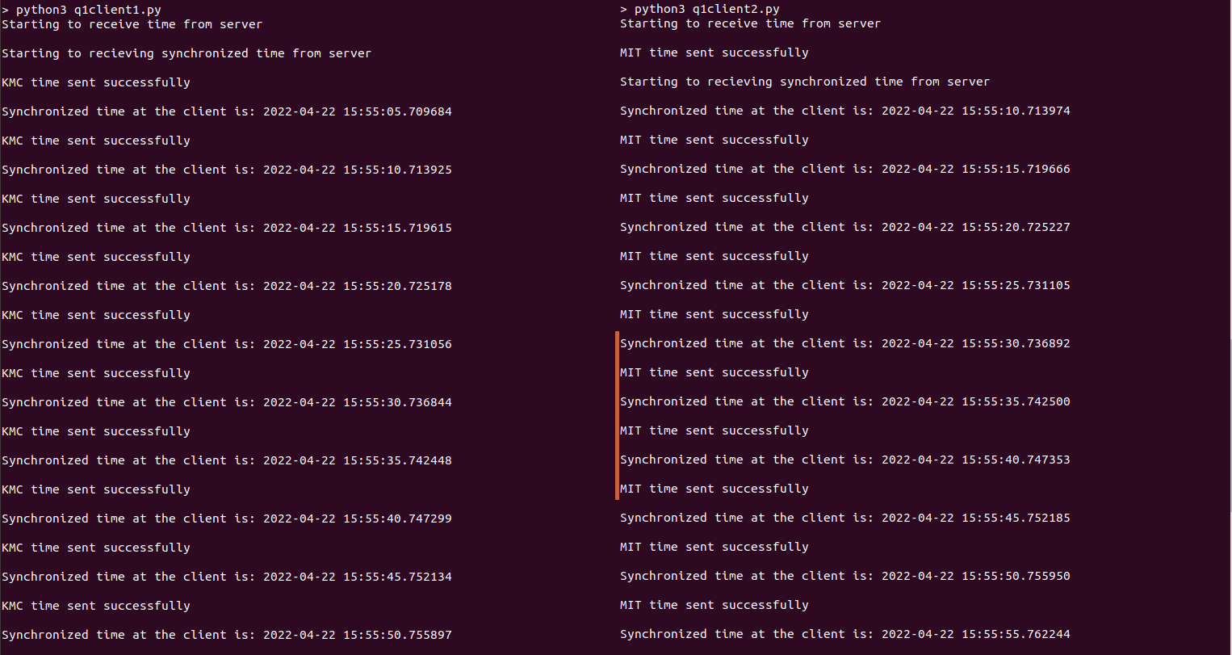

**Client 3 & Client 4**

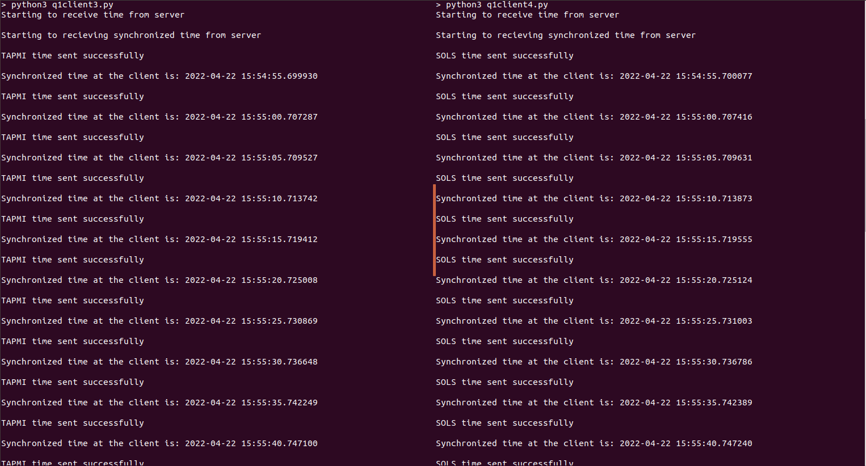

**2)**

**#server.py**

import socket

import datetime

import time

def initiateClockServer():

s = socket.socket()

print("Manipal Buddy Banking")

port = 8011

s.bind(('', port))

s.listen(5)

print("Waiting for client...")

while True:

connection, address = s.accept()

print('Server connected to', address)

connection.send(str(datetime.datetime.now()).encode())

connection.close()

if __name__ == '__main__':

initiateClockServer()

**#client1.py**

import socket

import datetime

import time

from dateutil import parser

from timeit import default_timer as timer

def synchronizeTime():

print("MOBILE APP\n")

s = socket.socket()

port = 8011

s.connect(('127.0.0.1', port))

request_time = timer()

server_time = parser.parse(s.recv(1024).decode())

response_time = timer()

actual_time = datetime.datetime.now()

print("Time returned by server: " + str(server_time))

process_delay_latency = response_time - request_time

print("Process Delay latency: " + str(process_delay_latency) + " seconds")

print("Actual clock time at client side: " + str(actual_time))

client_time = server_time + \

datetime.timedelta(seconds=(process_delay_latency) / 2)

print("Synchronized process client time: " + str(client_time))

time.sleep(10)

s.close()

if __name__ == '__main__':

synchronizeTime()

**#client2.py**

import socket

import datetime

import time

from dateutil import parser

from timeit import default_timer as timer

def synchronizeTime():

print("WEB BROWSER\n")

s = socket.socket()

port = 8011

s.connect(('127.0.0.1', port))

request_time = timer()

server_time = parser.parse(s.recv(1024).decode())

response_time = timer()

actual_time = datetime.datetime.now()

print("Time returned by server: " + str(server_time))

process_delay_latency = response_time - request_time

print("Process Delay latency: " + str(process_delay_latency) + " seconds")

print("Actual clock time at client side: " + str(actual_time))

client_time = server_time + datetime.timedelta(seconds = (process_delay_latency) /2)

print("Synchronized process client time: " + str(client_time))

time.sleep(10)

s.close()

if __name__ == '__main__':

synchronizeTime()

**Output:**

**Server**

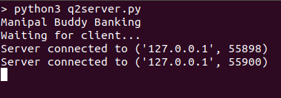

**Client1**



**Client2**

